**LAB # 1**

Introduction to GitHub

**OBJECTIVE**

Introduction to GitHub by creating Git repository and cloning its configuration to eclipse project.

**Lab Task:**

1. Create account on GitHub.

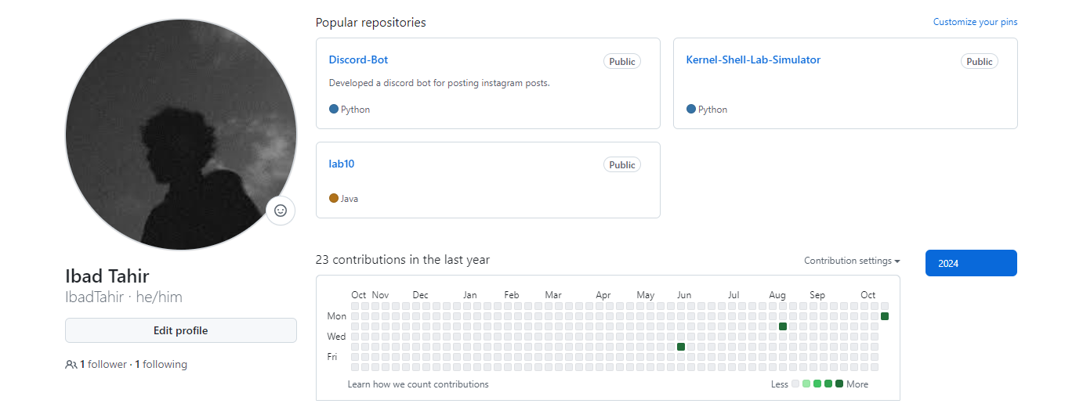

1. Upload any of your Java Project files and perform commit, push, pull and merge operations.

